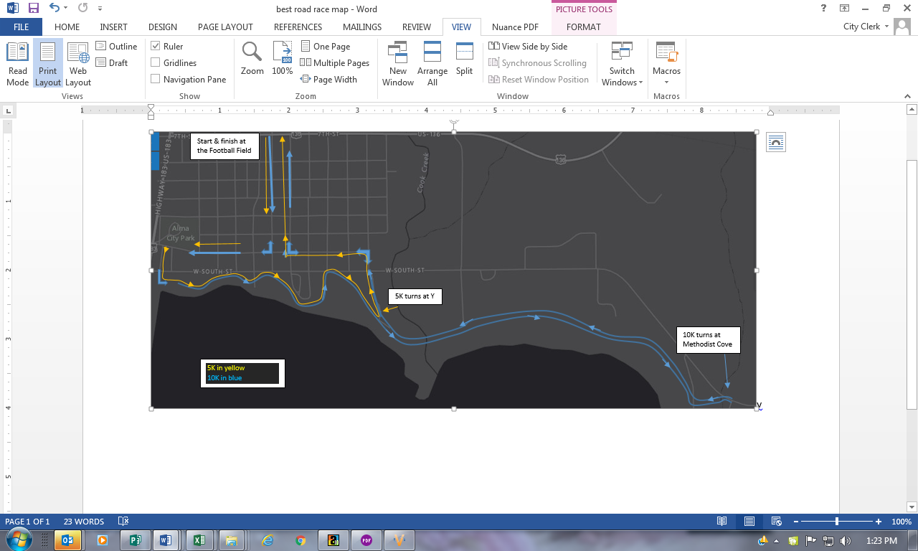

***Road Race 2022***

The Same Dam Site for 40 Years!

## Road Race Map

***July* 4th, 2022**

**Alma, NE**

**\*\* A Special Thanks to our Sponsors & Alma Chamber of Commerce Members and Volunteers! \*\***

***Sponsored by:***

***The Flower Patch***

*In conjunction with*

***Alma Chamber of Commerce***



The Flower Patch

PO Box 69

Alma, NE 68920

Road Race Sign-up Form

|  |  |  |  |  |  |  |
| --- | --- | --- | --- | --- | --- | --- |
| Sign up for:  (Check Event of Interest) | | Shirt Size  (Circle) | | |  |  |
| ❒ | Men’s 10k | Youth S | | |  | Adult L |
| ❒ | Women’s 10k | Youth M | | |  | Adult XL |
| ❒ | Men’s 5k | Youth L | | |  | Adult 2XL |
| ❒ | Women’s 5k | Adult S | | |  | Adult 3XL |
| ❒ | 2 Mile Fun run/walk | Adult M | | |  |  |
|  | | | | | | |
| Name (Please Print) | | | | | | |
| Address | | | | | | |
|  | | | | | | |
|  | | | | | | |
| Phone | | | | | | |
| E-mail | | | | | | |
| $25 Entry Fee Per Person  *Checks payable to Alma Chamber of Commerce*  Sign Up Link: https://runsignup.com/race/ne/alma/bestroadracebyadamsite    **Mail the Waiver Form, Sign-up Form, & Entry Fee to: The Flower Patch  *Family Plan (4 people & over) - $23 Per Person.  *Free Entry for the 2021 5k and 10k Winners!  *Go to [www.almacity.com](http://www.almacity.com) under the Current News to view a printable brochure and flyer. | | | | | | |
| Signature | | |  | Date | | |
| Age | | | | | | |

## Road Race 2022

## Awards

*Free T-Shirts to ALL participants registered by June 17, 2022

*Free entry for 2021 5k & 10k race winners

*Medals to top 3 places in men’s and women’s:

1) age divisions 2) 5k races 3) 10k races

*Must be present to win

You can find your race results at *almacity.com* & *almanechamber.com*

## Race Schedules/Divisions

*Check in 7-7:30am at Alma High School Football Field & Track.

*2 Mile Fun run/walk starts at 7:45am.

*5k and 10k races start at 8:00am.

*Entry Forms/Waiver Forms mailed to the Flower Patch with checks payable to Alma Chamber of Commerce.

The Flower Patch

PO Box 69

615 W Main St

Alma, NE 68920

Phone: 308-928-2888

**Flower Patch**

*We invite you to participate in the* ***“Best Road Race by a Dam Site”****! Races include a 10k, 5k, and a 2 mile Fun run/walk. These events are open to all participants of all abilities and we encourage you to enter regardless of your experience! The 10k is only open to runners and joggers, no walkers please.*

*Bring your whole family and spend the day in Alma! Included in the day’s activities are the following: Parade @ 10:30 am, Art and Lunch in the Park @ 11:30 am, Shopping, and Golf. Also available: Fishing, ATV-ing, Swimming, Water Skiing, Camping, and Fireworks at The Harlan County Reservoir @ 10 pm.*

*Call Terri Bach at #308-928-2888 for more information.*

# 

Waiver Form

I am entering at my own risk and assume any responsibility for injuries I may incur as a direct result of participation in this event. I hereby release and waive my heirs and executors for any and all rights and claims for damages against the Alma Chamber of Commerce, Flower Patch, or the Road Race Event officials for injuries suffered by me in connection with the event. I fully understand the entry fees are non-refundable.

Signature

_________________________________________

Parent/Guardian Signature (if 18 or younger)